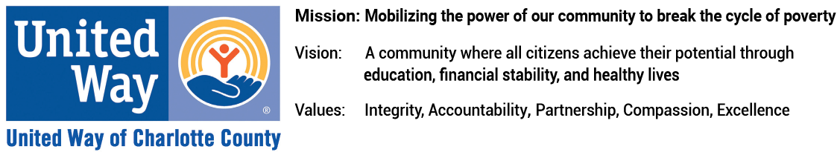

FINANCE ASSISTANT
ORGANIZATION
United Way of Charlotte County is mobilizing the power of our community to break the cycle of poverty. Our workplace is fast-paced, friendly, and adaptive. People with diverse backgrounds and abilities are encouraged to apply. Join us in giving everyone in our community the opportunity to live their best life. We are seeking a Finance Assistant – this team member is critical to success of our mission.
You are a good fit for this position if:
- You are interested in a part-time position of 18 hours per week;
- You have Quick Books experience;
- You are detail oriented with strong analytical, problem solving and decision making skills with ability to manage and analyze data sets;
- You have the ability to work collaboratively and multi-task in a fast-paced environment, handling multiple projects and data sources;
- You have excellent verbal and written communication skills;
- You are able to perform intermediate business math and accurate data entry;
- You are an independent self-starter; motivated to seek out new opportunities to review and analyze data to support strategic decision-making; comfortable with embracing change

Job Responsibilities/Duties Include:
- Receives incoming pledges, cash, checks, EFTs and contribution data files for processing based on review of open pledges receivable, processing requirements, information from internal data external web portals.
- Creates, processes and mails donor thank you letters
- Processes accounts payable for grants
- Creates reports and dashboards needed by RD staff and executive leadership team to manage their portfolios and track progress against revenue and activity goals.
- Enters contribution and related information into electronic forms on behalf of donors as needed, extracts, manipulates and standardizes electronic data files to prepare for or support processing, submits requests for gift, pledge and payment adjustments, and tracks follow-through.
- Maintains and updates donor and agency accounts
- Works with other departments and teammates to research and resolve internal and external inquiries.
- Prepares reports and analysis related to donor gifts and related data sets for internal and external use and to support business decisions.
- Assists with database administration and maintenance including designing and implementing protocols and training staff.
- Produces regular revenue reports for RD and Finance teams, as well as senior leadership, to track funds raised against goals, illustrate significant trends and inform revenue projection adjustments.
- Works with senior staff to reconcile projected revenue with actuals.
- Provides administrative support for United Way Foundation of Charlotte County as required.
- May provide external customer support as needed, including answering and directing phone calls.
- Performs other duties as assigned.
Qualifications
- Associates’ degree, or equivalent, in business administration, accounting, or a related field
- Three years’ experience in data processing or office administration
- Intermediate proficiency in Microsoft Office Suite (Word, Excel and Access)
- Quick Books experience
- Strong familiarity with donor databases, data mining, and reporting.
- Access to reliable transportation, proof of insurance, and a valid driver’s license
- Demonstrated excellence in project management, communication and organizational skills

UNITED WAY CORE COMPETENCIES FOR ALL STAFF
- Mission-Focused: Catalyze others’ commitment to mission to create real social change that leads to better lives and healthier communities. This drives their performance and professional motivations.
- Relationship-Oriented: Understands that people come before process and is astute in cultivating and managing relationships toward a common goal.
- Collaborator: understands the roles and contributions of all sectors of the community and can mobilize resources (financial and human) through meaningful engagement.
- Results-Driven: Dedicated to shared and measurable goals for the common good; creating, resourcing, scaling, and leveraging strategies and innovations for broad investment and impact.
- Brand Steward: Steward of the brand and understands his/her role in growing and protecting the reputation and results of the greater network.

PHYSICAL REQUIREMENTS
The employee is regularly required to communicate clearly, in oral and written formats, with others in person, over the phone, and via other devices. The employee must be able to transcribe, read extensively, prepare and analyze data and figures, operate a computer and other standard office machinery.

Email your resume to admin@unitedwayccfl.org
or deliver to:
17831 Murdock Circle, Suite A, Port Charlotte, FL 33948
No phone inquiries.

